Web Crescendo Training Exercise 1.3

Create a Contact Us Form and Associate with a Web Page

Create and Configure a Contact Us Form:

There are two steps involved in completing the Contact Us form for the web page: create the form and then configure the fields you want in the form.

- Select Contact Us in the Portlets folder and click on the ‘+’ to the left of “Portlet Actions for CONTACT”.

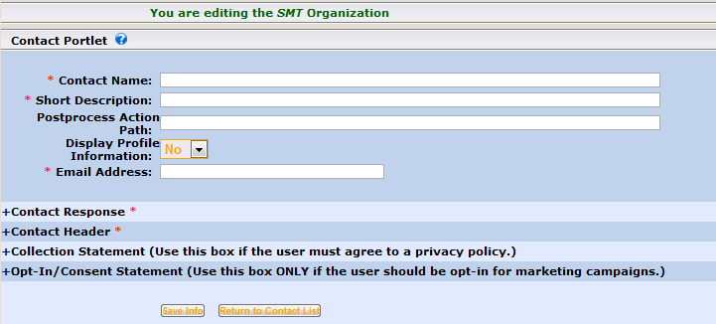

- All fields with an * must be completed. Enter your information in the “Email Address:” field. Contact Response is the verbiage shown following the submission of the contact information. The Contact Header is the verbiage shown as the Title of the contact form. The other fields will be discussed at a later time. Remember to click on when finished.
- Find the form you just created in the Contact Us list and select the icon located to the right, under Actions, to configure it. Click in the next to the field(s) you would like available in the Contact form. If a field is not available that you want on your form, create it by clicking on the ‘+’ next to the “Fields for the Contact Form”. You must determine the ‘Order’ in which the fields are to be presented on the form. Note: We advise that you NOT choose sequential numbers when defining the order of the fields. This makes it easier when additional fields are added to the form because it will prevent complete reordering. The ‘Required’ attribute will force the user to complete those fields before submitting his/her information. Remember to click on when finished.
- Before adding the form to a web page, click on the icon, locate to the right under Actions to preview your form. Make any modifications, clicking on when finished.

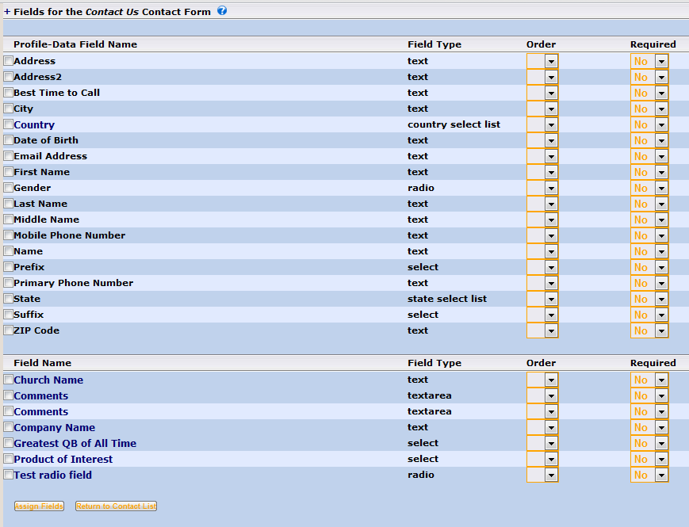

Create a Subpage:

- Locate the web page you created in a previous exercise and select the icon located to the right under Actions to add a subpage to your page. Fill out the appropriate fields and remember to click on when finished. Notice there is now a ‘+’ icon to the left of your web page.

Associate your Contact Us form with the subpage.

- Navigate to the subpage just created. Select the Associate Portlets icon located to the right of the subpage under Actions. Click the ‘+’ icon to the left of “Portlets on the … Page”.

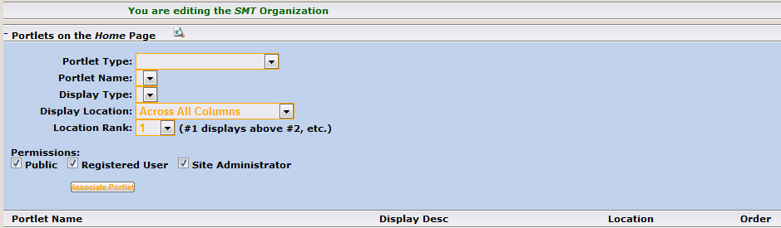

- When you select ‘Contact Us’ in the “Portlet Type:” drop-down list, the “Portlet Name” drop-down list will populate with all available Contact Us forms. Remember to click on when all attributes have been configured.

- Select the preview icon for the subpage created, fill in the Contact Us form and submit. You will receive an email containing the contents typed into the Contact Us form.

