Web Crescendo Training Worksheet 1.1

Create and Associate a Survey Portlet

Create a Survey
- Log into the Command Center and select your organization.
- Navigate to the Portlets folder and select Surveys. A list of surveys created for your organization appears.

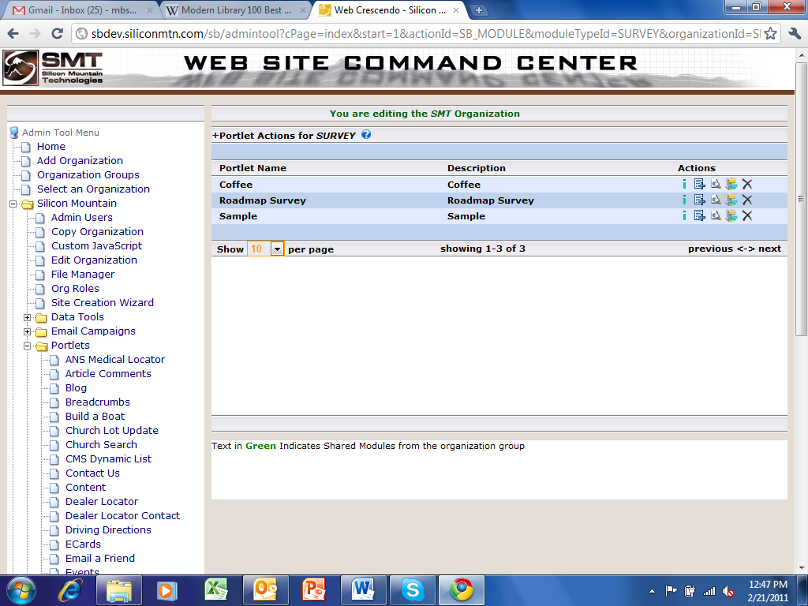

- Add a Survey by clicking on the ‘+’ next to “Portlet Actions for SURVEY”. Develop a Survey that might pertain to your company. (Think about the type of questions that might be contained in the survey – this will be important in the next step.) Leave the No/Yes options set to ‘No’ except for the Notify Admin, which should be set to ’Yes’. The text in the WYSIWYG tool will apply to the response the user sees after completing the survey. Enter your e-mail address in the “Notify Email Address field”. Create a survey response sentence in the tool.

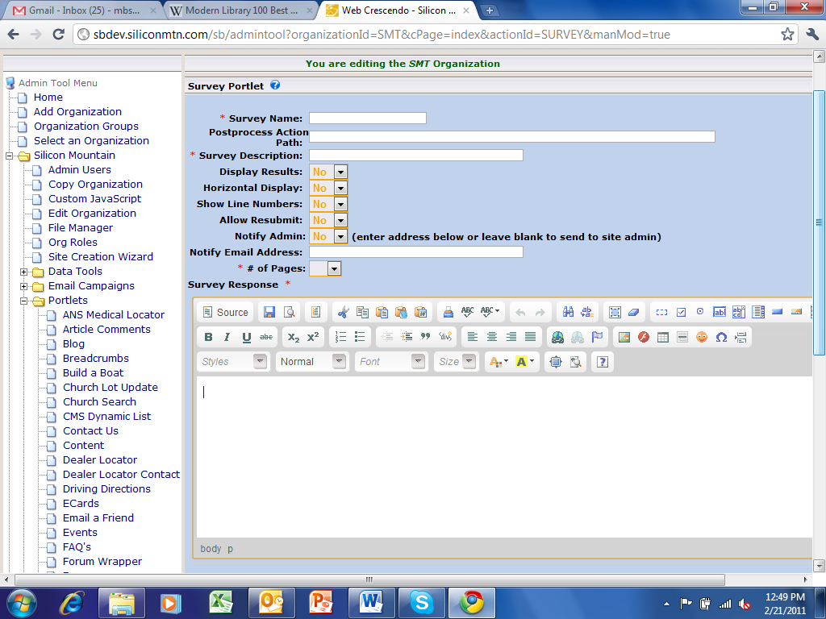
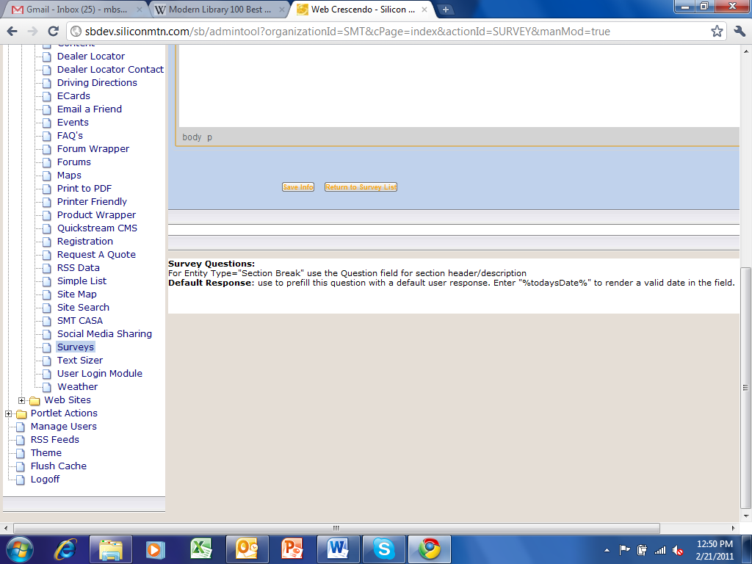

- Set the # of Pages field to 1. The page updates to include a Header Text section for that page. Click on the ‘+’ to the left of “Page 1 Header Text:” to display the WYSIWYG tool and the “Submit Button Label:” field. Don’t forget to click on when you have finished.
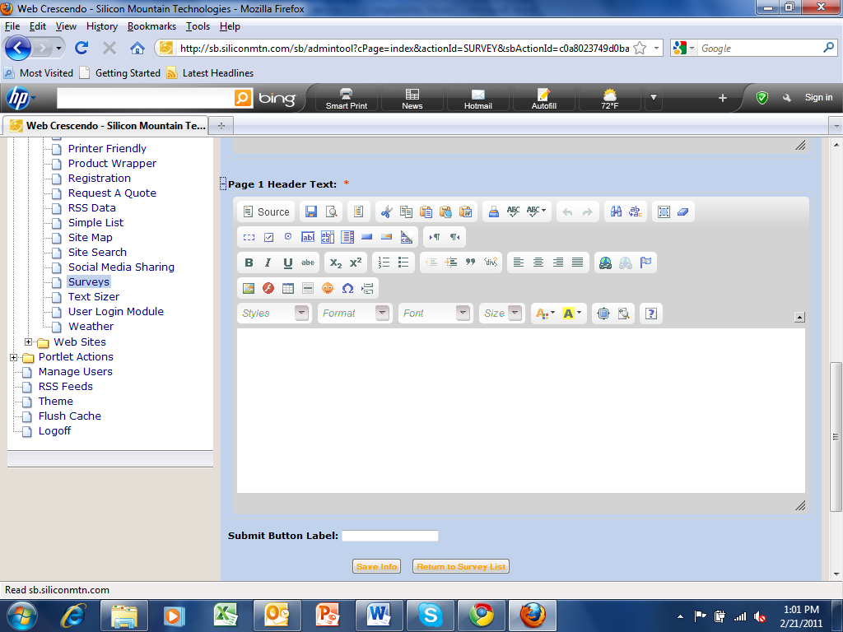

- Find your survey in the library of surveys and select the icon located to the right, under Actions.
- Click on the ‘+’ to the left of “Questions for the Sample Survey”.

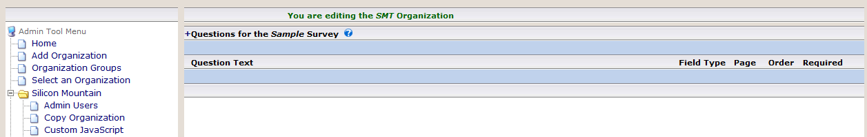

- The New Survey Question form appears. This form allows you to configure each question of the survey. Don’t forget to click on when you have finished each survey question.

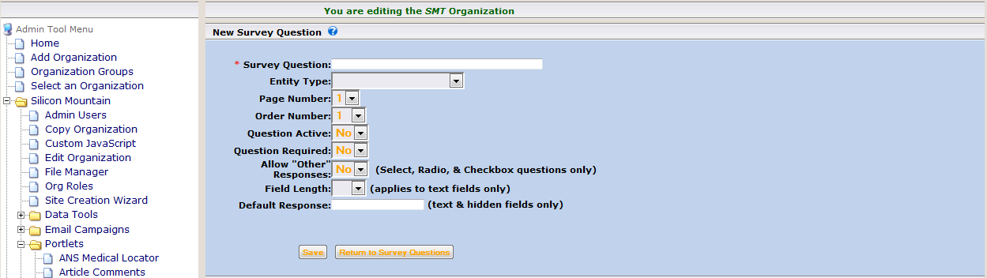

Associate the Survey to a web page.
- Navigate to the web page you created in the first exercise.
- Select the icon located to the right of your page.
- Click the + icon located on the top right of your screen to add your survey to the page.

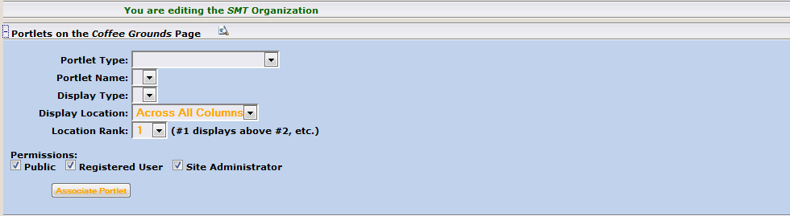

- The Display Type (Default View), Display Location (Default 2) and the Location Rank (4).
- Remember to click on when finished configuring the survey association.
- To view the page you just created, Select Pages and then select the icon located to the right of the page you just created.
- Complete the survey you created and submit the answers. A response to the survey should appear in your inbox.

