Web Crescendo Training Exercise 1.0

Creating a Web Page and a Content Portlet

Create a Web Page. This requires that you first select an Organization to which this page will be associated.

- Log into the Command Center and select the organization.

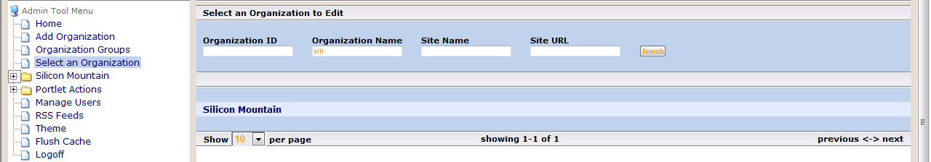
1
2
3
4

- Add a page to a website in the organization chosen above, understanding that the ‘Add Page’ icon you use determines where it will be added. At this point you might want to record the location of the web page you are adding.

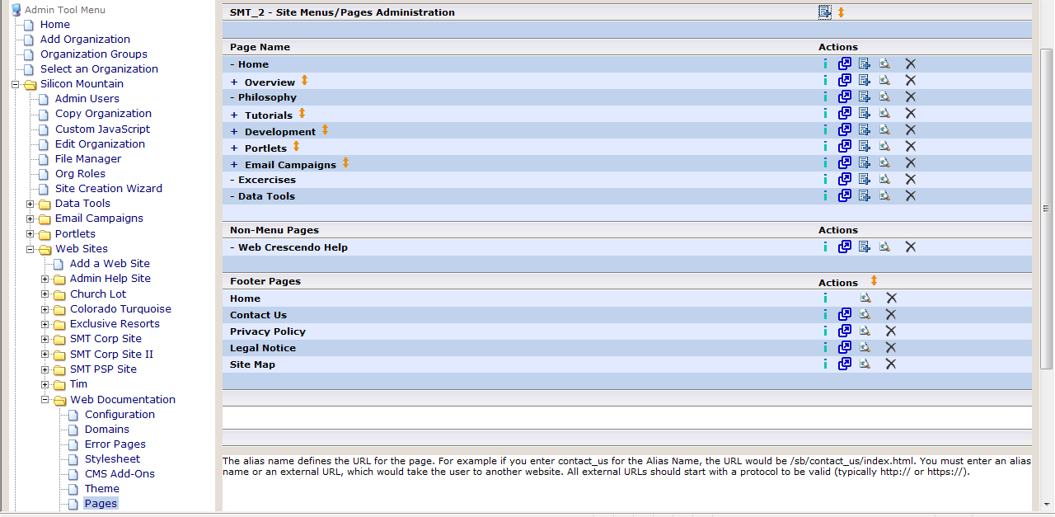
1
2
3
4
5

- Adding a web page is as simple as defining only the attributes with an *. Notice the URL displayed below the Alias field.

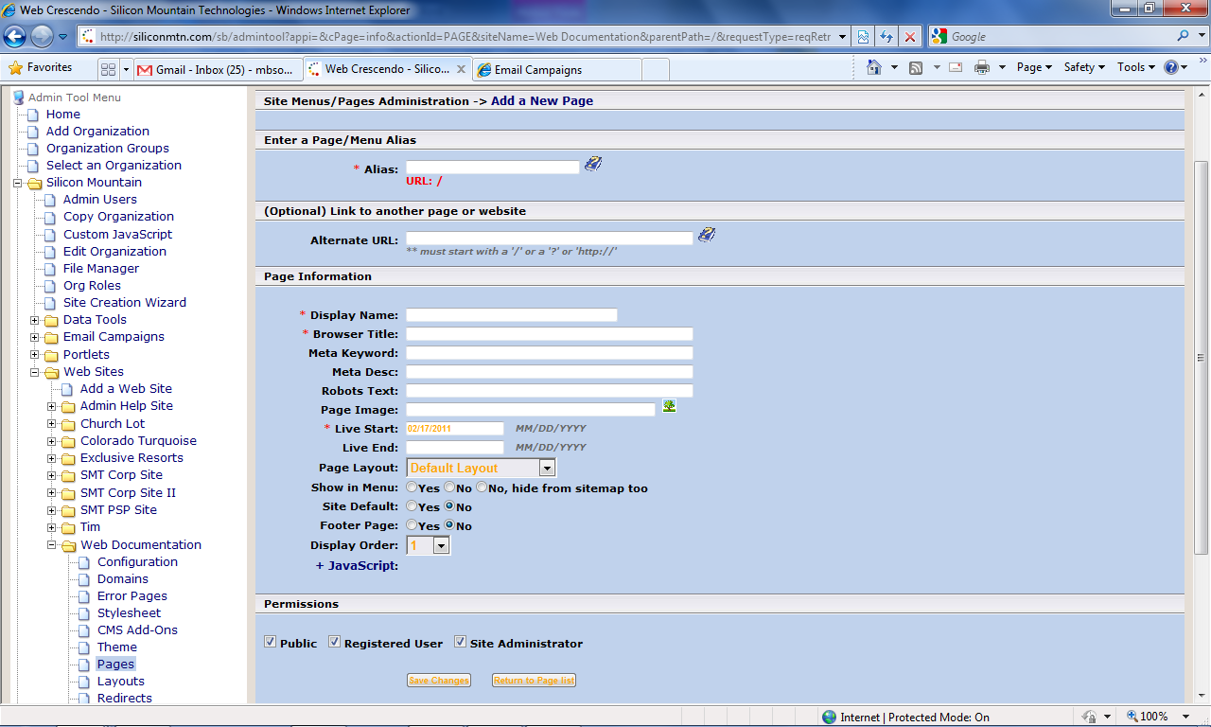

- Don’t forget to when finished.

Create a Content Portlet.

- Portlets are found in the Portlets folder.

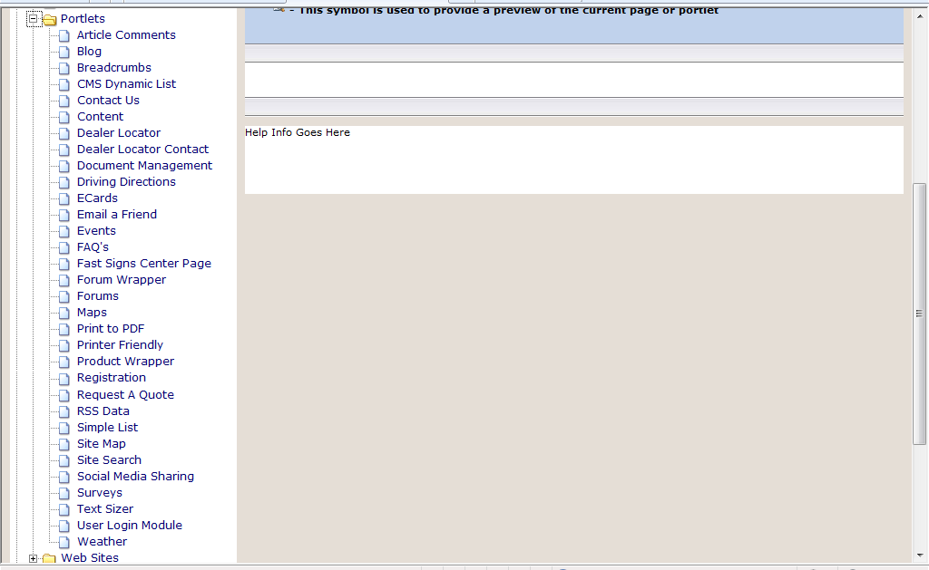

- Clicking on the Content Portlet displays a list of portlets created for the Organization. Notice the Organization is displayed in green above the Content Window. A Content Portlet is added by clicking on the ‘+’ sign located next to “Portlet Actions for CONTENT”.

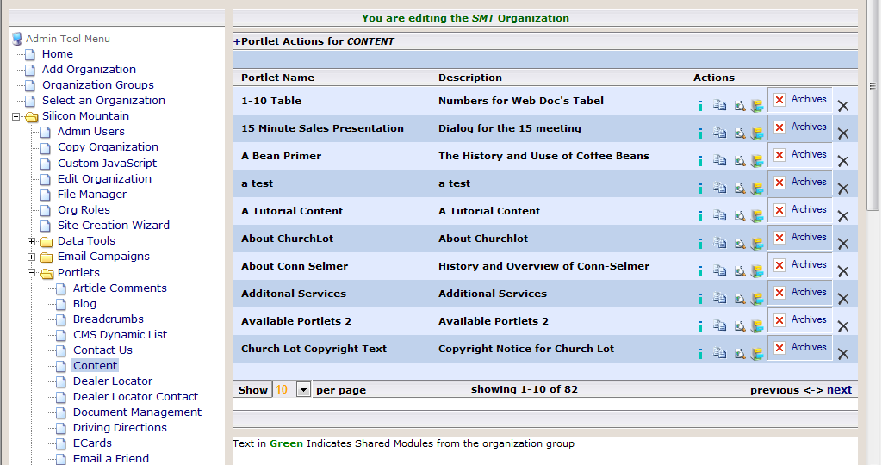

- The window that appears is called the WYSIWYG (what you see is what you get) tool. Give your Content Portlet a Name and Description. Type some content into the body of the WYSISYG tool. Don’t forget to 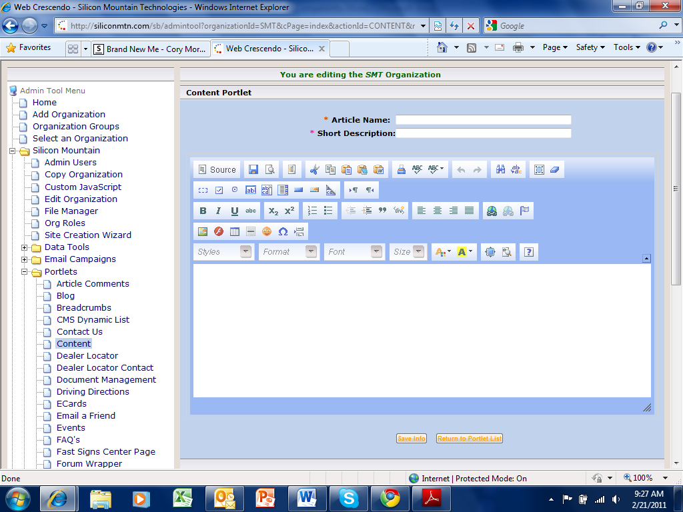 after you have finished writing the content.

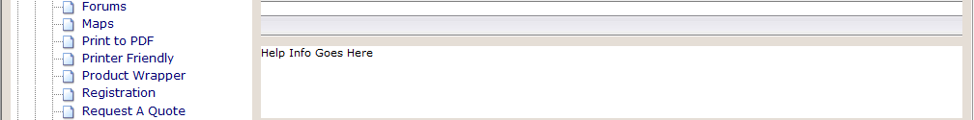

Associate the Portlet with your Web Page

- Locate the page you added in the first step of this exercise. (The screen grab shown below is an example of what you might see but not the actual contents.)

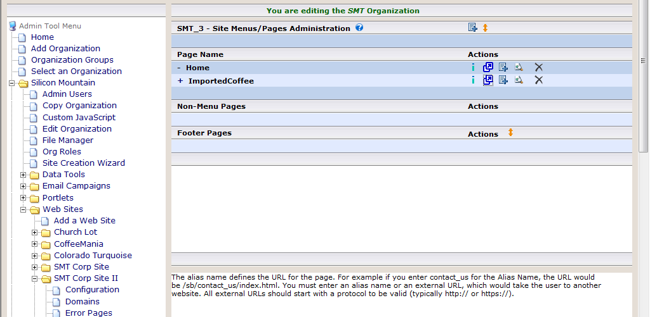

- Select the (Associate Portlets) icon located to the right of your listed page.

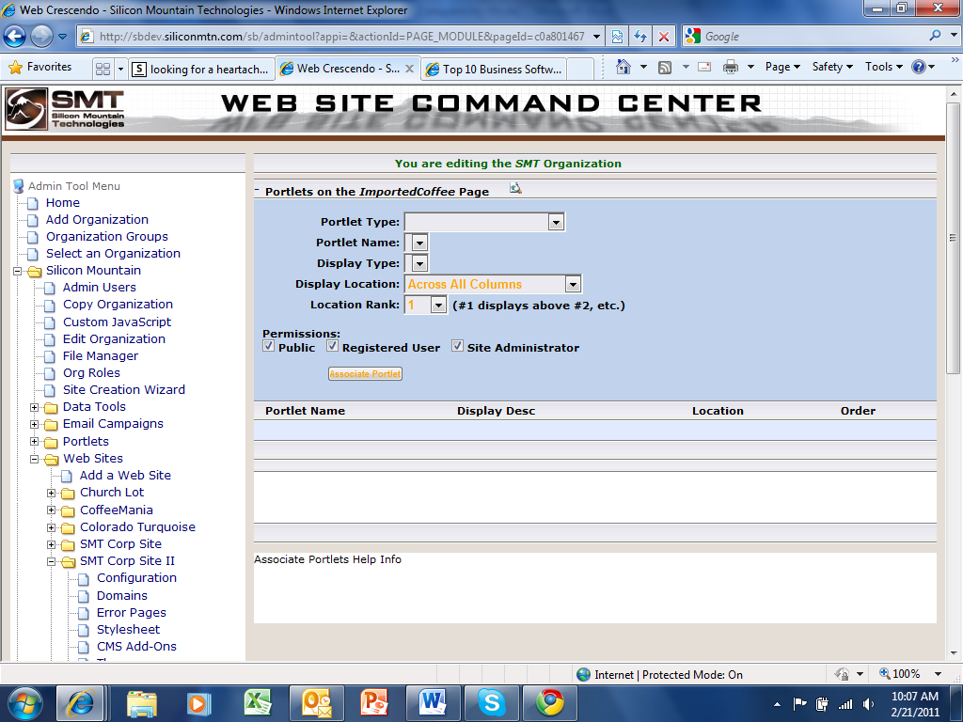

Choosing Portlet Type: of Content will change the Portlet Name: list that appears below it. The portlet you created will appear in the portlet name list. In most cases, as in this case, the Display Type: chosen from the list is No Formatting. The choices listed for Display Location: is determined by the layout of the web page. Don’t forget to after configuring the Portlet.
- To view the page you just created, Select Pages and then select the icon located to the right of the page you just created.

