Web Crescendo Training Exercise 1.6

Creating a Website, Layout and Changing a Theme

Create a Web Site. This requires that you first select an Organization to which this page will be associated.

- Log into the Command Center and select the organization.

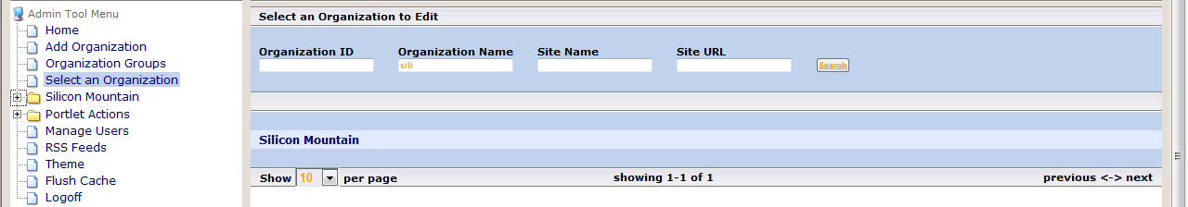
1
2
3
4

- Add a new website in the organization chosen above and completed all fields necessary. Select Save. (Note: to edit a website, select “Configuration” under the websites folder.

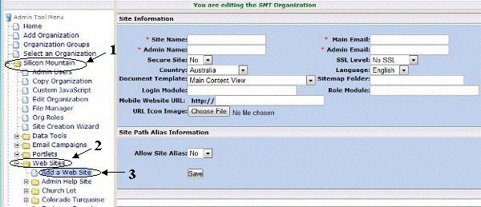

- To add a new Domain select the + icon (Location 5). To add Domain Keys, select the icon. Note: You can only have ONE primary domain.
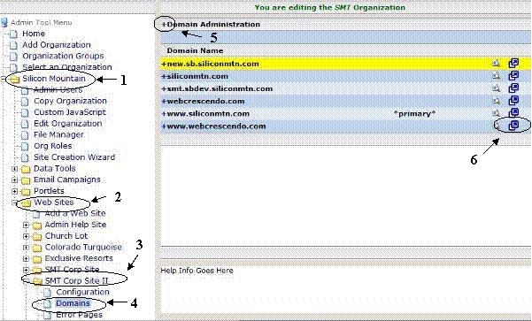

- Choose the domain key being added and enter its value. Select: Add Key. Go ahead and add a Google analytics key with a made up value.

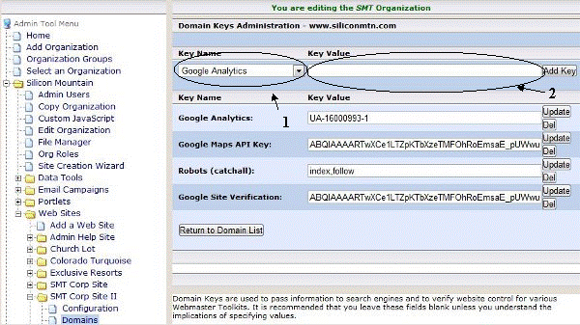
Creating a new layout and associating a Portlet with that layout.

- Select: Layouts from the folder tree structure. Add a new layout.
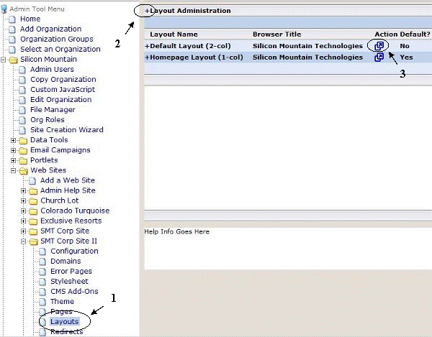

- Complete all required information and give this layout 2 columns making column 1 the default column. Select “Add Layout”. (Note: you can only have ONE default layout.)

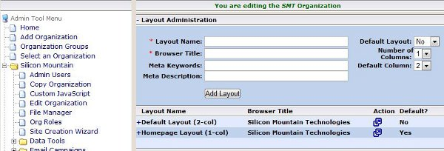
Select the icon and associate a portlet with that layout. If you need to, create a piece of content and then associate that content.

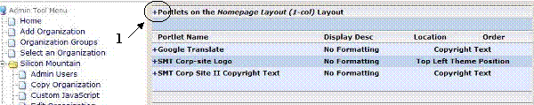

- Complete all fields and select “Associate Portlet”.

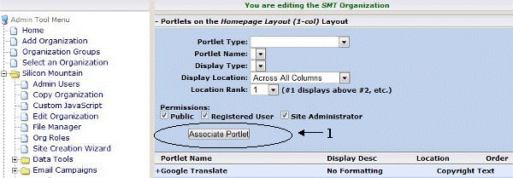

Changing the Theme of your site.

When you create a new website, you are automatically given a default theme. Select Themes and change the theme of your website.

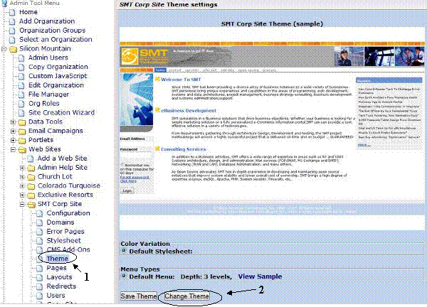
- Browse through the library of Themes and choose one of your likings. Select the image to view a larger image of that Theme.

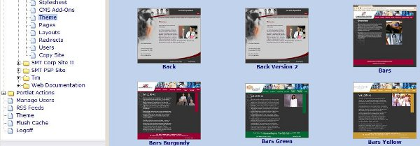
- One you have chosen your new theme, determine the color variation and menu types. Select Change Theme.

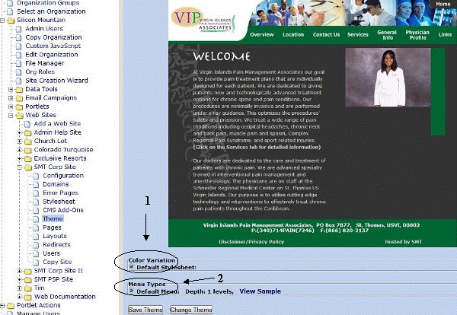

Add a new page to your website with the layout you created and associated a new piece of content in both column 1 and 2.

